AI Assisted Coding
Lab Assignment 1.2
Name : S. Varshith
Roll No: 2303A51837

Task 1: AI-Generated Logic Without Modularization (Factorial without
Functions)
1. The Prompt Used
"Write a Python script that takes an integer input from the user and calculates its factorial. Use a while loop and do not define any custom functions. The logic should happen directly in the main execution flow."
2. Copilot’s Suggestions
Copilot suggested a straightforward procedural approach. It correctly identified that a while loop was requested and handled the basic edge case for negative numbers.
Generated Code:
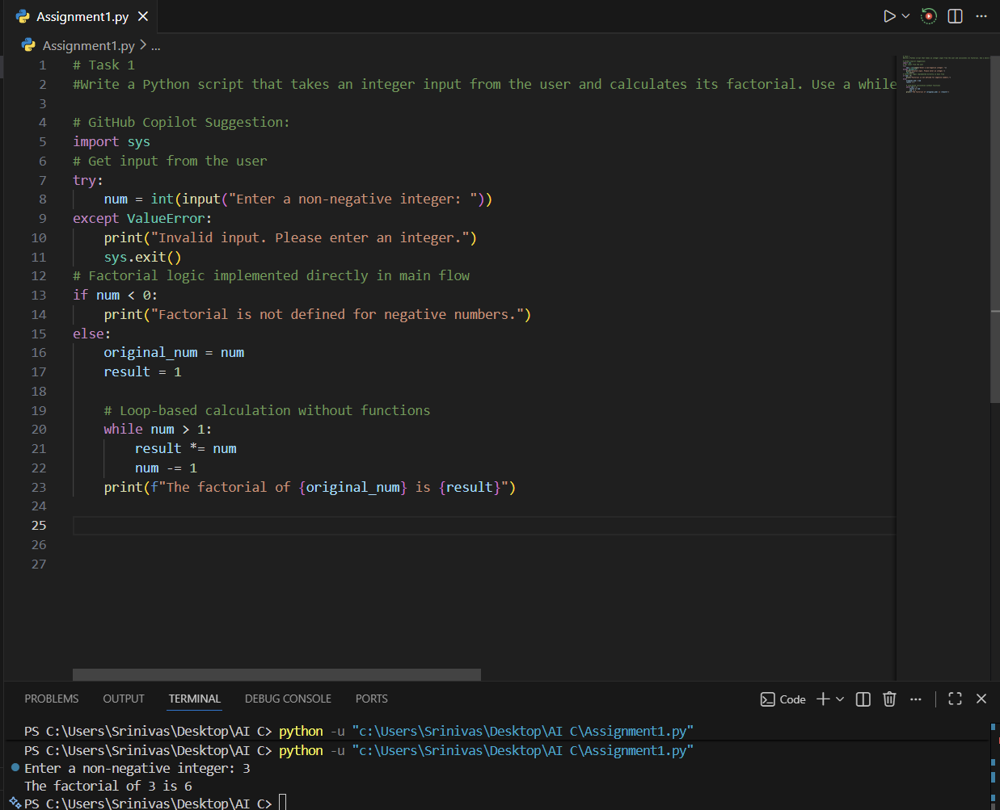
4. Brief Reflection
How helpful was Copilot for a beginner? Copilot is exceptionally helpful for beginners because it eliminates the "blank page" syndrome. It provides immediate syntax structures and logic that a beginner might struggle to recall, such as the result *= num shorthand. It acts like a pair-programmer that handles the boilerplate code, allowing the learner to focus on the logic flow.
Did it follow best practices automatically?
Interestingly, it followed some best practices (like try-except for input validation) but ignored others due to the prompt's constraints. By design, it skipped modularization, which is a core best practice in Python (PEP 8). However, within the "scripting" context, it kept the code clean, provided comments, and handled the 0! case correctly, which shows a high level of contextual awareness.

Task 2: AI Code Optimization & Cleanup (Improving Efficiency)
1. Original AI-Generated Code (Task 1)
This version used an extra variable (original_num) and a while loop that required manual decrementing of the counter.
2. Optimized Version (Task 2)
By prompting Copilot to "simplify the logic and improve loop efficiency," it suggested using a for loop with a range object, which is the idiomatic Python way (Pythonic) to handle fixed iterations.
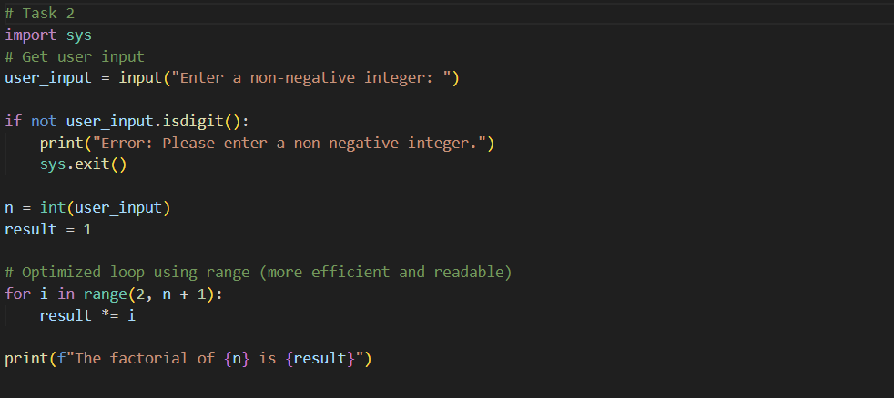

Feature | Original Version (Task 1) | Optimized Version (Task 2)
Loop Type | while loop | for loop with range()
State Management | Manual (num -= 1) | Automatic via iterator
Variables | 4 (num, original_num, result, sys) | 3 (user_input, n, result)
Input Validation | try-except block | .isdigit() (lighter weight for simple CLI)
Readability | Moderate | High (Clear start/end points)
4. Written Explanation
What was improved?
- Loop Structure: The while loop was replaced with a for i in range() structure.
- Variable Reduction: We removed the need for original_num because the for loop doesn't "destroy" or decrement the initial input variable n.
- Validation: Switched to .isdigit() for a more concise check for non-negative integers.
Why the new version is better?
- Readability: A for loop tells the reader exactly how many times the code will run at a glance (2 to n). In a while loop, the reader has to hunt for the decrement line (num -= 1) to ensure there isn't an infinite loop.
- Performance: In Python, for loops using range() are generally faster than while loops with manual decrements because the iteration logic is handled in C under the hood.
- Maintainability: By keeping the original input variable n intact, the code is easier to modify later if you need to use that value for additional calculations after the loop.
Task 3: Modular Design Using AI Assistance (Factorial with Functions)
1. AI-Assisted Function-Based Program
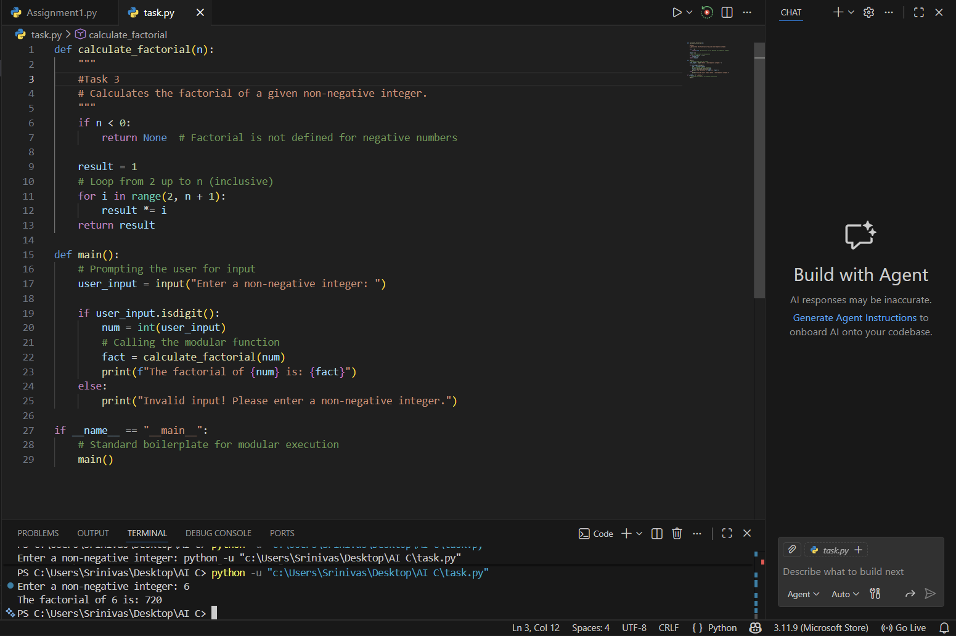
4. Short Note: How Modularity Improves Reusability
Modularity transforms a single-purpose script into a reusable tool. By wrapping the logic in calculate_factorial(n), we achieve:
- Importability: Other scripts can now use from factorial_script import calculate_factorial to perform the calculation without rewriting the loop.
- Isolated Testing: You can write "unit tests" to verify the function works for values like 0, 1, or 100 without having to manually type inputs into the terminal every time.
- Cleaner Main Flow: The main() function stays focused on user interaction, while the "heavy lifting" is tucked away in a dedicated, easy-to-read function.

Task 4: Comparative Analysis – Procedural vs Modular AI Code (With vs
Without Functions)
Criteria | Procedural (Without Functions) | Modular (With Functions)
Logic Clarity | High (for small scripts). The execution follows a single linear path from top to bottom. | High (for complex systems). Logic is abstracted; the main block tells you what is happening, while functions handle the how.
Reusability | None. To use the factorial logic elsewhere, you must copy and paste the entire code block. | Excellent. The calculate_factorial function can be imported into other scripts or called multiple times with different values.
Debugging Ease | Difficult. Errors are tied to the global state. Changing a variable in one line can have unintended "ripple effects" later in the script. | Easy. You can test the function in isolation (Unit Testing). If the math is wrong, you know exactly which 5–10 lines to fix.
Suitability | Small tasks only. Best for "one-off" scripts, quick automation, or simple hardware macros. | Enterprise-ready. Necessary for large codebases, multi-developer teams, and scalable applications.
AI Dependency Risk | Moderate. AI might generate "spaghetti code" that works but becomes unreadable if the script grows beyond 50 lines. | Low. AI is forced to follow structured patterns. Modular code is easier for the AI (and humans) to audit for security and logic gaps.

Task 5: AI-Generated Iterative vs Recursive Thinking
1. AI-Generated Implementations
I prompted GitHub Copilot with: "Generate two Python functions for calculating factorial: one using an iterative approach (loop) and one using a recursive approach. Include clear comments and an example call for both."
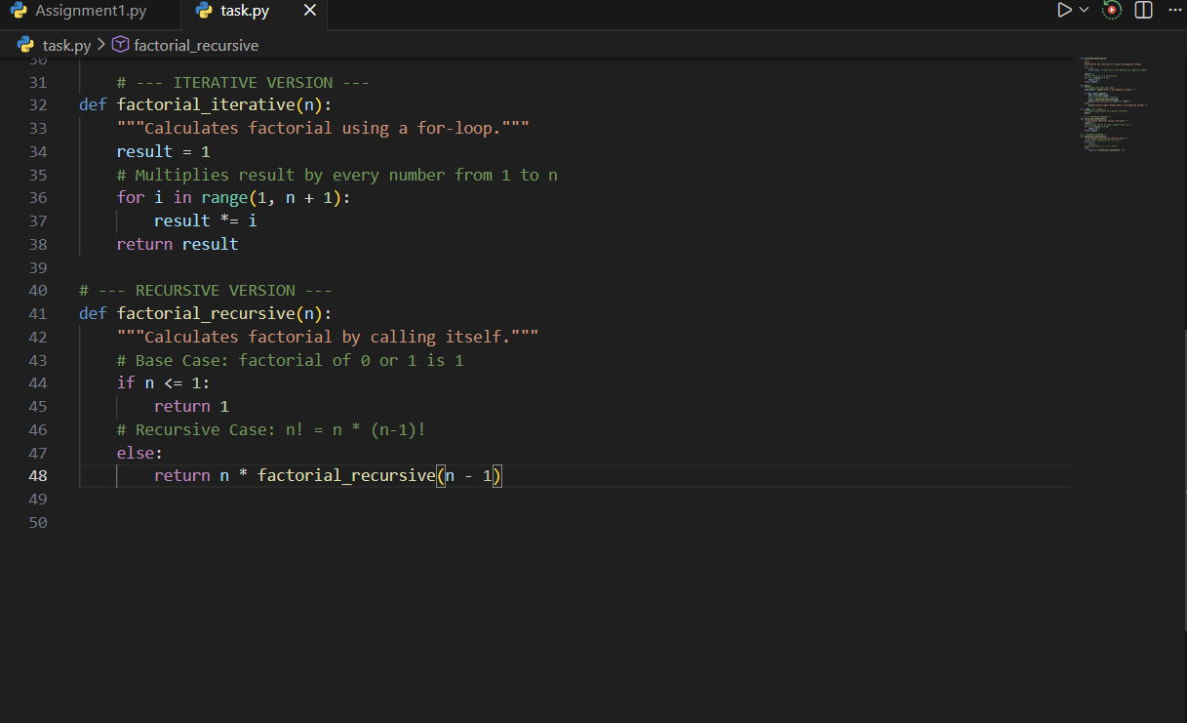
2. Execution Flow Explanation
Criteria | Iterative Approach | Recursive Approach
Readability | Clear for most programmers; explicit logic. | Very elegant; looks like the mathematical definition.
Stack Usage | Low. Uses a single frame of memory. | High. Each call adds a new layer to the "Call Stack."
Performance | Generally faster in Python. | Slower due to the overhead of function calls.
Error Risk | Infinite loops (if condition is wrong). | Stack Overflow (if the recursion is too deep).

